Observational studies in the Lancet: [formatting guidelines](https://www.thelancet.com/pb/assets/raw/Lancet/authors/ObservationalGuidelines-1688712280923.pdf)

Words: 3500

References: 30

Authors:

Lucinda Hiam, Benjamin Goodair,

Matthew Wallace

Jon Minton

Martin McKee / Rob Aldridge

Aly?

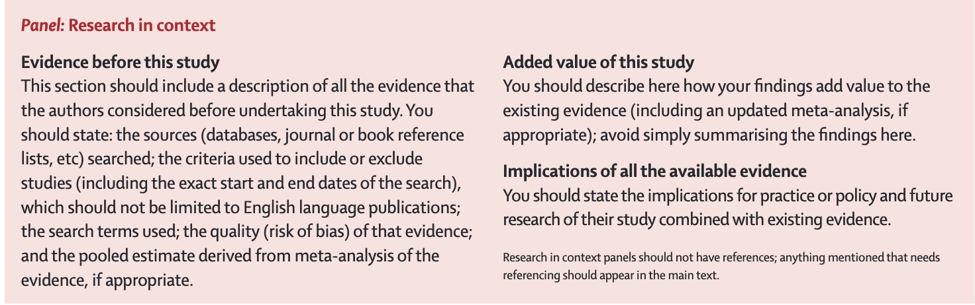

1. **Summary**

*Maximum length 300 words.*

1. **Background**
2. **Methods**
3. **Findings**
4. **Interpretation**
5. **Funding**

No funding to report.

1. **Copyright**
2. **Translated abstract**

N/a.

1. **Introduction**

* *Provide the scientific background and rationale for your study, providing references for data presented and studies mentioned.*
* *State the specific objectives, including any prespecified hypotheses.*

Life expectancy is a key indicator of a population's health and well-being. Over the past century, England and Wales experience a steady rise in life expectancy, but this trend stalled and reversed since the mid-2010s.1 Understanding the drivers behind this shift is essential for informing health and social policy. Migrants, defined here as people living in England & Wales but born outside the UK, make up 16.8% (10 million) of the population,2 with demographic shifts in recent year, linked to Brexit and changes in immigration policy.3 However, the impact of migrants on UK life expectancy is still underexplored.

Evidence from other high-income countries (HICs) suggests that migrants can positively affect national life expectancy.4–9 In the United States, life expectancy has also stagnated since 2010 and declined almost every year since 2015.10 Ho and Hendi found that without migrants, the deterioration in life expectancy would have been substantially worse.5 Wallace et al. examined life expectancy in the Nordic region and found that immigrants in Denmark, Finland, and Norway generally have higher life expectancy than native-born populations, contributing positively to national trends, while in Sweden, immigrants initially had lower life expectancy but reached parity by 2019, shifting from a negative to positive impact.4 These trends influenced the rankings of life expectancy across the Nordic region.

The positive contribution of migrants to life expectancy is attributed to the 'healthy migrant effect', a phenomenon where migrants often exhibit lower mortality rates compared to the native-born population,11,12 thought to be due to, in part, the selective nature of migration, where healthier individuals are more likely to migrate.13,14 However, this effect can fade over time as migrants assimilate into their new environment, which may include adopting less healthy lifestyles, limited healthcare access,15 and the harms of discrimination.16 Additionally, mortality differences among migrants vary by factors such as country of origin,4,17 disease category,16–19 migration status (e.g. economic migrant, refugee) and socio-economic status.11 Thus, the impact of migration on life expectancy is not uniform and requires a nuanced investigation.

The paper seeks to address the research question: What is the impact over time of migrants on national life expectancy at birth in England & Wales? The objectives are to establish the impact of migrants on life expectancy at birth in England & Wales between 1971 and 2011, s how these have changed over time and to explore and quantify recent changes in life expectancy trends in England & Wales.

We hypothesise that, as demonstrated in other HICs, migrants in England & Wales will have contributed positively to national life expectancy trends, and that without the positive contribution to national life expectancy trends of migrants, recent stalling of improvements in life expectancy could have been greater.

This paper will explore the policy implications of migration on health and social services in a post-Brexit UK, with evolving immigration patterns. By examining the link between migration and life expectancy, it aims to provide evidence for public health initiatives and immigration policy. As England and Wales grow more diverse, understanding migrant health dynamics is essential for ensuring equitable health outcomes for all residents

1. **Methods**
2. **Study design**

We calculate the period life expectancy based on annual cohorts of individuals residing in the UK between 1971 and 2011. We use linked census and life events data for a 1% sample of the population of England and Wales (cite ons ls) to estimate population life expectancy. We then model life expectancy according to whether residents are born inside the UK, or outside, to calculate the different life expectancies – and the impact that migration has on national life expectancy in the UK.

We provide a GATHER checklist Appendix xxx. R (version xxx) were used for statistical analysis. A full coding library is available along with files for reproduction on a simulated dataset at https://github.com/BenGoodair/migration_life_expectancy.

1. **Data**

We use data from the ONS’ Longitudinal Study – a resource detailing the life events of all people born on four days in the calendar year (cite). The total sample between 1971 and 2011 includes xxxx people, xxxx births, xxxx deaths and xxxx migrations into the UK.

A full description of the data, including missing data, and data limitations is available in the appendix xxx.

1. **Statistical analysis**

We calculate life expectancy following the ONS definition of period lifetables, with infant mortality adjusted according to xxx. Full life tables for each year are published in the repository (<https://github.com/BenGoodair/migration_life_expectancy>). For each year, the calculation is produced chronologically as follows:

𝑚𝑥 = 𝑑𝑒𝑎𝑑𝑥/((𝑎𝑙𝑖𝑣𝑒𝑥+𝑑𝑒𝑎𝑑𝑥)/2)mx = deadx/alivex+deadx/2

Where

𝑚𝑥mx

 refers to the mortality rate at a given age

𝑥 x

,

𝑑𝑒𝑎𝑑𝑥deadx

 is the total number of people who die during a given age, and

𝑎𝑙𝑖𝑣𝑒𝑥alivex

 is the number alive people at the beginning of age

𝑥 x

.

𝑥 x

is all ages ranging from 0 to 105.

𝑎𝑥 = 0.5ax = 0.5

And for females:

𝑎0 = 0.14903−2.05527∗𝑚0a0 = 0.14903−2.05527∗m0

and for males:

𝑎0 = 0.14929−1.99646∗𝑚0a0 = 0.14929−1.99646∗m0

Where

𝑎𝑥ax

 is a central age function – which identifies the midpoint of age

𝑥 x

for all ages – except for age 0. At age 0, mortalities are skewed towards zero, and so the central age function is adopted to reflect this (cite Jon’s matertial).

𝑞𝑥=𝑚𝑥/(1+(1−𝑎𝑥)∗𝑚𝑥)qx=mx/1+1−ax∗mx

Where

𝑞𝑥qx

 is the probability of dying at a given age based on the observed mortality rate and central age function. With these functions

𝑚𝑥mx

,

𝑞𝑥qx

, and

𝑎𝑥ax

, we can construct a period life table for each year, enabling us to calculate life expectancy.

𝑙0=10,000l0=10,000

𝑑𝑥=𝑞𝑥∗𝑙𝑥dx=qx∗lx

𝑙𝑥=𝑙𝑥−1−𝑑𝑥−1lx=lx−1−dx−1

Where

𝑙0l0

 is a synthetic cohort of 10,000 people in a given year,

𝑙𝑥lx

is the remaining cohort, reducing for each age by the expected deaths (

𝑑𝑥dx

) in all previous ages and

𝑑𝑥dx

 is the synthetic number of expected deaths at any given age from the remaining cohort or

𝑙𝑥lx

. From these values you can calculate life expectancy.

𝑡𝑥=∑105𝑥𝑙𝑥tx​=∑x105​lx

𝑒𝑥 = 𝑡𝑥𝑙𝑥ex = txlx

Where

𝑡𝑥tx

is the total number of person-lives lived from the synthetic cohort of 10,000 for all ages

𝑥 x

and above. And, finally,

𝑒𝑥ex

is the life expectancy at a given age.

We present our results as life expectancy at age 0, with secondary analysis presenting results at age 16, 25, 60 – to observe how the effect of migration on life expectancy might vary across the life course.

1. **Sensitivity and robustness analysis**

Our analysis is run on a sample of the UK population – meaning that we are conducting an inference to the whole UK population. To perform such an inference, we provide confidence intervals to estimate levels of uncertainty. We bootstrap the results with 1,000 iterations and calculate the 95% confidence intervals around that.

We present a number of robustness checks including comparing our life expectancy calculations to those presented by the ONS and HMD. We also recalculate the HMD life expectancy results using our exact code to identify the differences in methods – rather than in underlying data.

1. **Role of the funding source**

*Not relevant.*

1. **Results**

**Figure 1. Life expectancy for UK born, Outside-UK born, and all UK residents.**

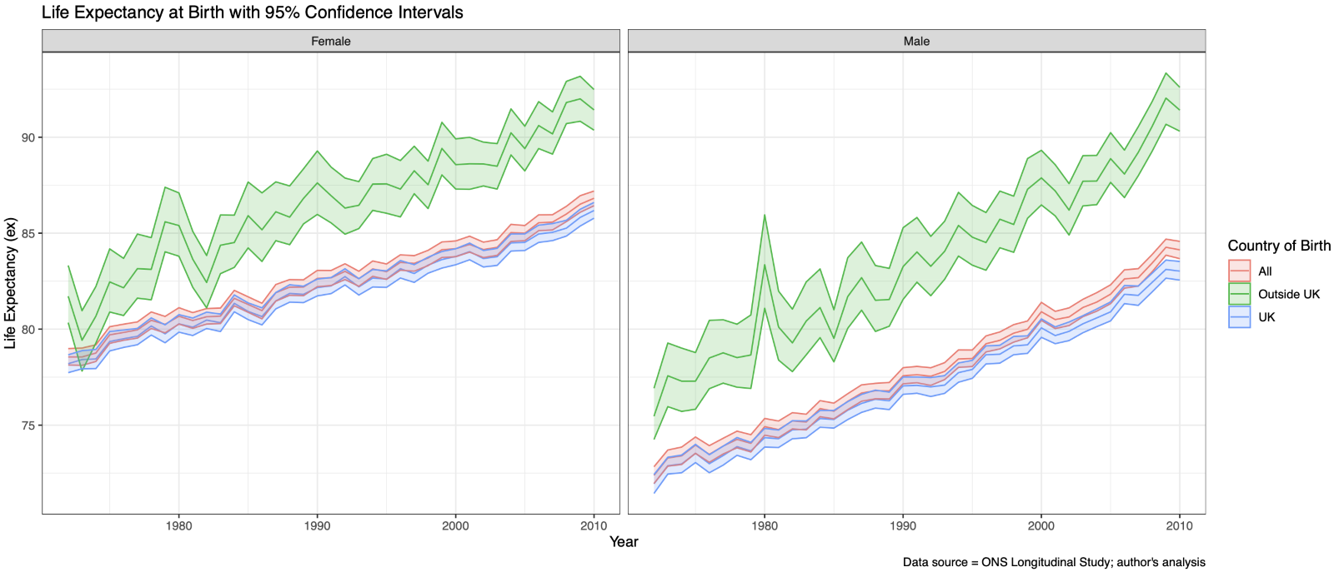**Figure 2. UK and Outside-UK born life expectancies at varying ages**

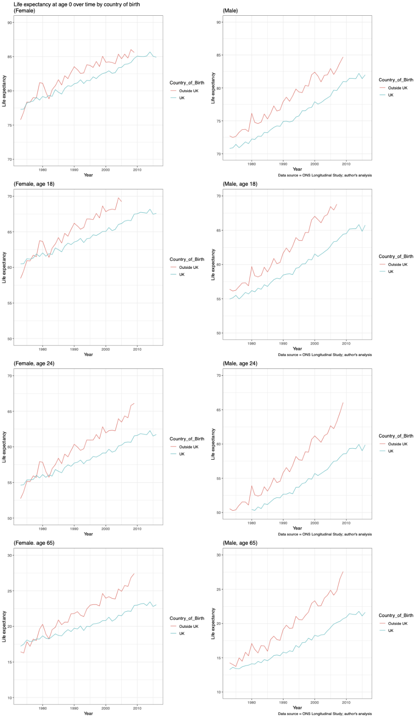

**Figure 3. The effect of migration on national life expectancy in the UK 1971-2009**

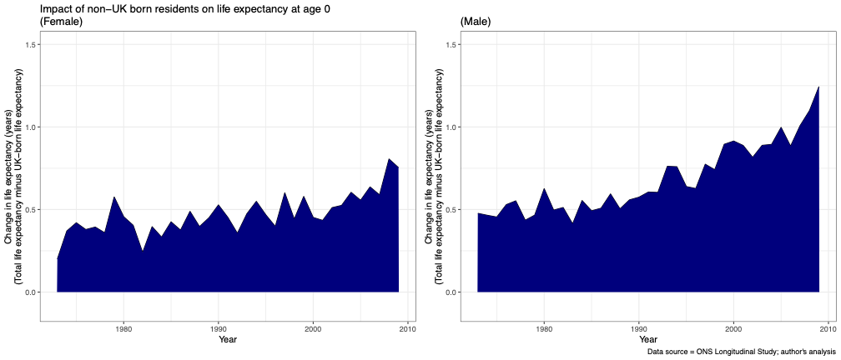

1. **Discussion**

Notes:

* These results hide the reality for many migrants living in England and Wales. A wide body of research have demonstrated the harms barriers etc.
* Selection acculturation
* Austerity
* Impact on recent stagnation/falls

1. **References**

1. Office for National Statistics. National life tables – life expectancy in the UK. https://www.ons.gov.uk/peoplepopulationandcommunity/birthsdeathsandmarriages/lifeexpectancies/bulletins/nationallifetablesunitedkingdom/2020to2022 (2024).

2. Office for National Statistics. International migration, England and Wales. https://www.ons.gov.uk/peoplepopulationandcommunity/populationandmigration/internationalmigration/bulletins/internationalmigrationenglandandwales/census2021 (2021).

3. Office for National Statistics. Long-term international migration, provisional - Office for National Statistics. https://www.ons.gov.uk/peoplepopulationandcommunity/populationandmigration/internationalmigration/bulletins/longterminternationalmigrationprovisional/yearendingdecember2023 (2024).

4. Wallace, M. *et al.* Immigration, mortality, and national life expectancy in the Nordic region, 1990–2019. *SSM - Population Health* **19**, 101177 (2022).

5. Hendi, A. S. & Ho, J. Y. Immigration and improvements in American life expectancy. *SSM - Population Health* **15**, 100914 (2021).

6. Hiam, L. *et al.* What can the UK learn from the impact of migrant populations on national life expectancy? *J Public Health (Oxf)* (2022) doi:10.1093/pubmed/fdac013.

7. Page, A., Begg, S., Taylor, R. & Lopez, A. Global comparative assessment of life expectancy: the impact of migration with reference to Australia. *Bull World Health Organ* **85**, 474–481 (2007).

8. Mehta, N. K., Elo, I. T., Engelman, M., Lauderdale, D. S. & Kestenbaum, B. M. Life Expectancy Among U.S.-born and Foreign-born Older Adults in the United States: Estimates From Linked Social Security and Medicare Data. *Demography* **53**, 1109–1134 (2016).

9. Preston, S. H. & Elo, I. T. Anatomy of a Municipal Triumph: New York City’s Upsurge in Life Expectancy. *Population and Development Review* **40**, 1–29 (2014).

10. Dattani, S., Rodés-Guirao, L., Ritchie, H., Ortiz-Ospina, E. & Roser, M. Life Expectancy. *Our World in Data* (2023).

11. Aldridge, R. W. *et al.* Global patterns of mortality in international migrants: a systematic review and meta-analysis. *The Lancet* **392**, 2553–2566 (2018).

12. Shor, E. & Roelfs, D. A Global Meta-analysis of the Immigrant Mortality Advantage. *International Migration Review* **55**, 999–1028 (2021).

13. Wallace, M., Khlat, M. & Guillot, M. Mortality advantage among migrants according to duration of stay in France, 2004–2014. *BMC Public Health* **19**, 327 (2019).

14. Guillot, M., Khlat, M., Elo, I., Solignac, M. & Wallace, M. Understanding age variations in the migrant mortality advantage: An international comparative perspective. *PLoS One* **13**, e0199669 (2018).

15. World Health Organisation. *World Report on the Health of Refugees and Migrants*. https://www.who.int/publications-detail-redirect/9789240054462 (2022).

16. Devakumar, D. *et al.* Racism, xenophobia, discrimination, and the determination of health. *The Lancet* **400**, 2097–2108 (2022).

17. Wallace, M. & Kulu, H. Mortality among immigrants in England and Wales by major causes of death, 1971–2012: a longitudinal analysis of register-based data. *Social Science & Medicine* **147**, 209–221 (2015).

18. Bhala, N., Bhopal, R., Brock, A., Griffiths, C. & Wild, S. Alcohol-related and hepatocellular cancer deaths by country of birth in England and Wales: analysis of mortality and census data. *J Public Health (Oxf)* **31**, 250–257 (2009).

19. Wild, S. H., Fischbacher, C., Brock, A., Griffiths, C. & Bhopal, R. Mortality from all causes and circulatory disease by country of birth in England and Wales 2001-2003. *J Public Health (Oxf)* **29**, 191–198 (2007).

20. Wild, S. H., Fischbacher, C. M., Brock, A., Griffiths, C. & Bhopal, R. Mortality from all cancers and lung, colorectal, breast and prostate cancer by country of birth in England and Wales, 2001-2003. *Br J Cancer* **94**, 1079–1085 (2006).

21. Wild, S. & McKeigue, P. Cross sectional analysis of mortality by country of birth in England and Wales, 1970-92. *BMJ* **314**, 705–710 (1997).

1. **Supplementary Material**